**Setup Google Account and Machines**

Create an Instance Template

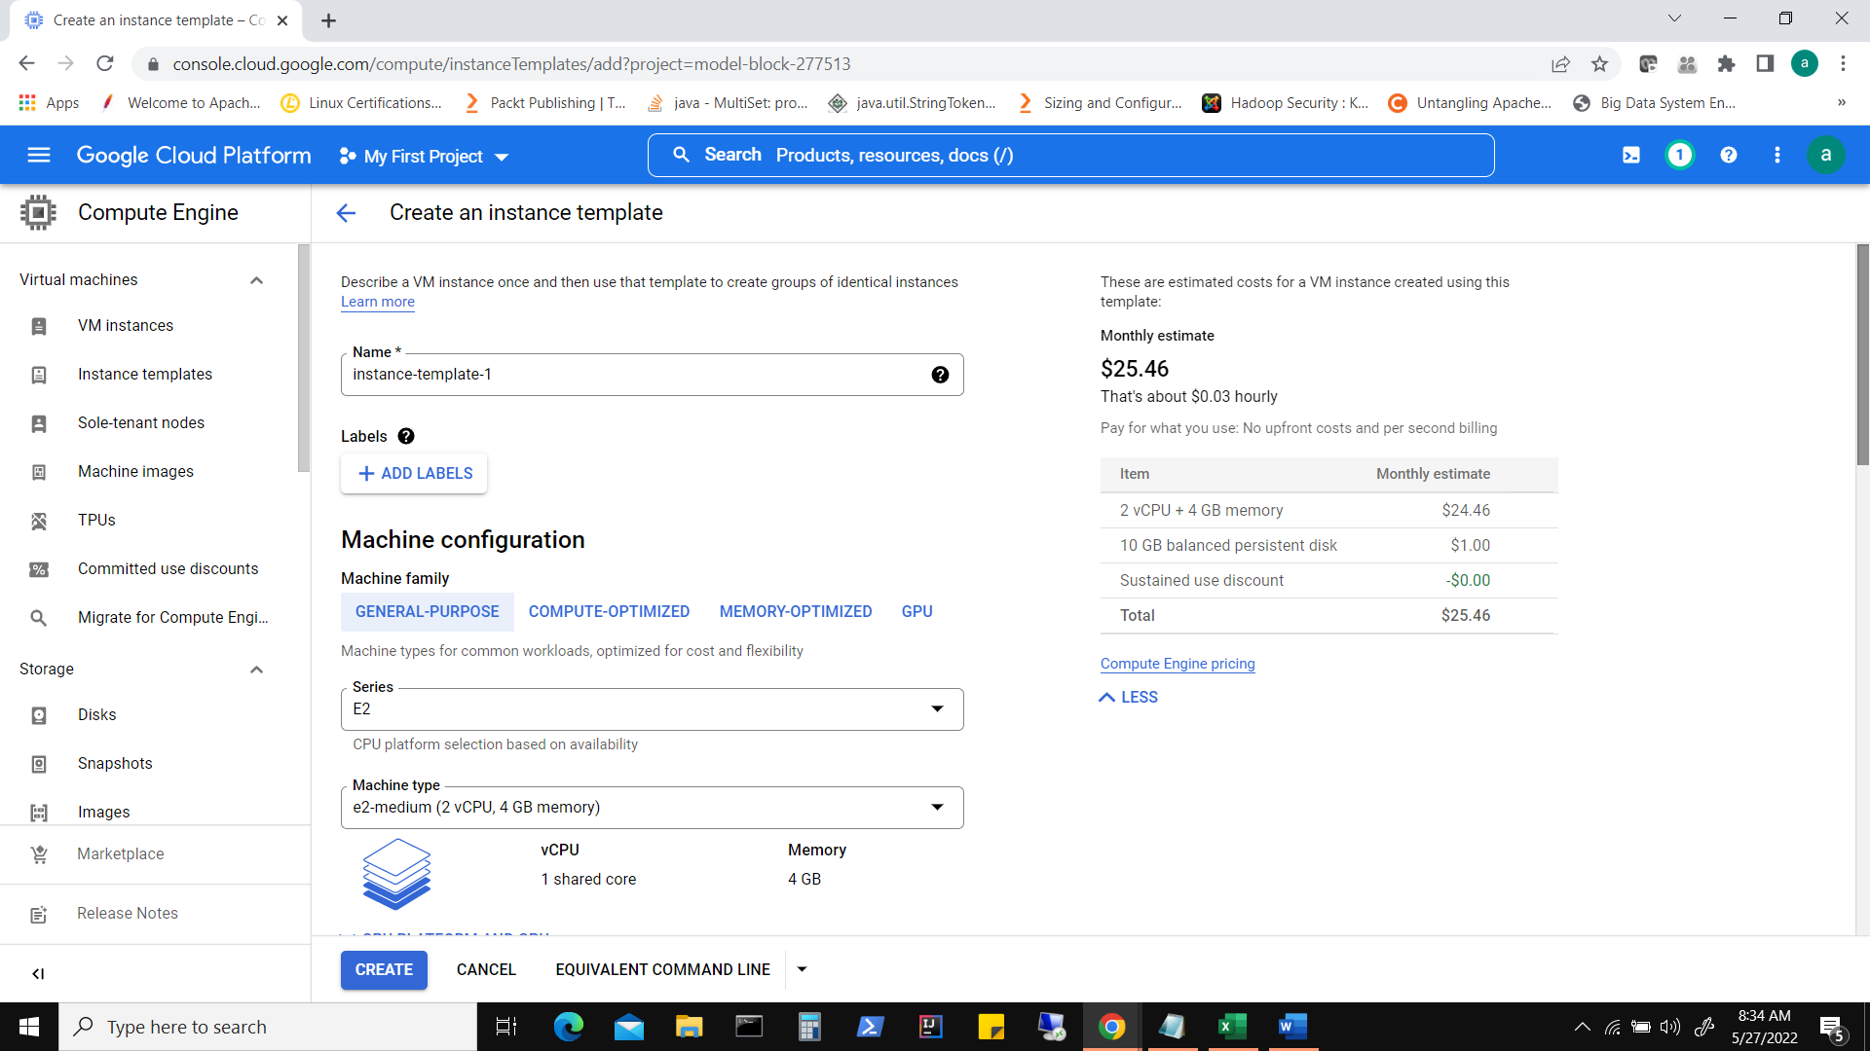

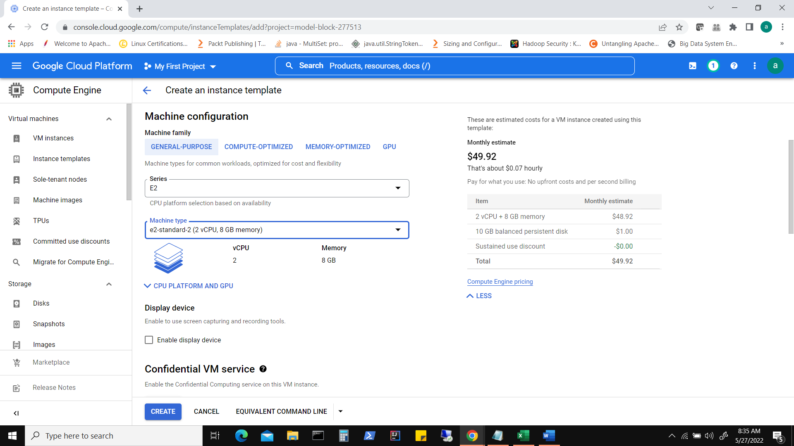

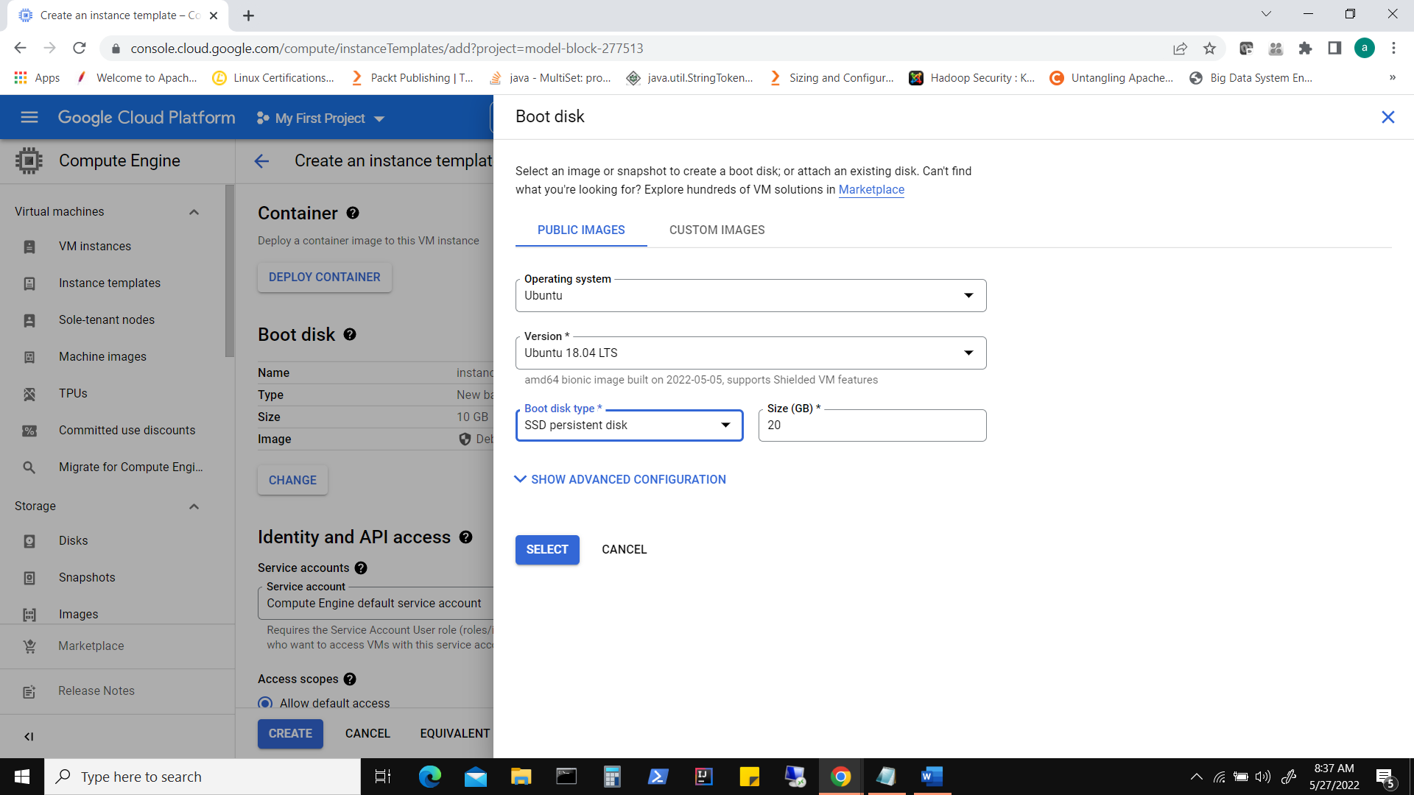

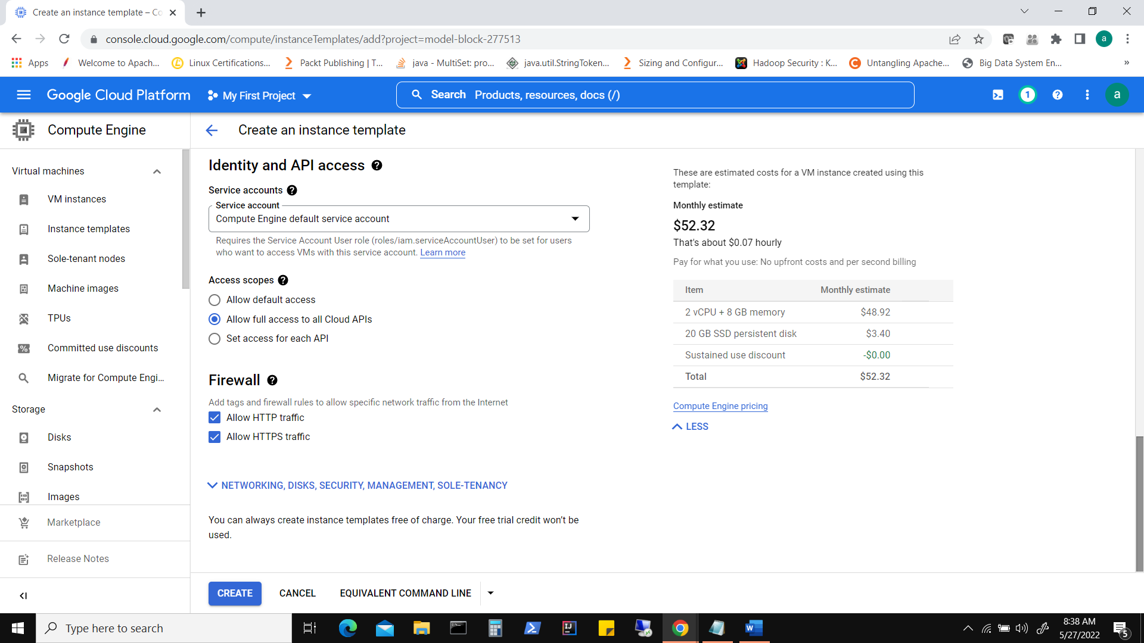

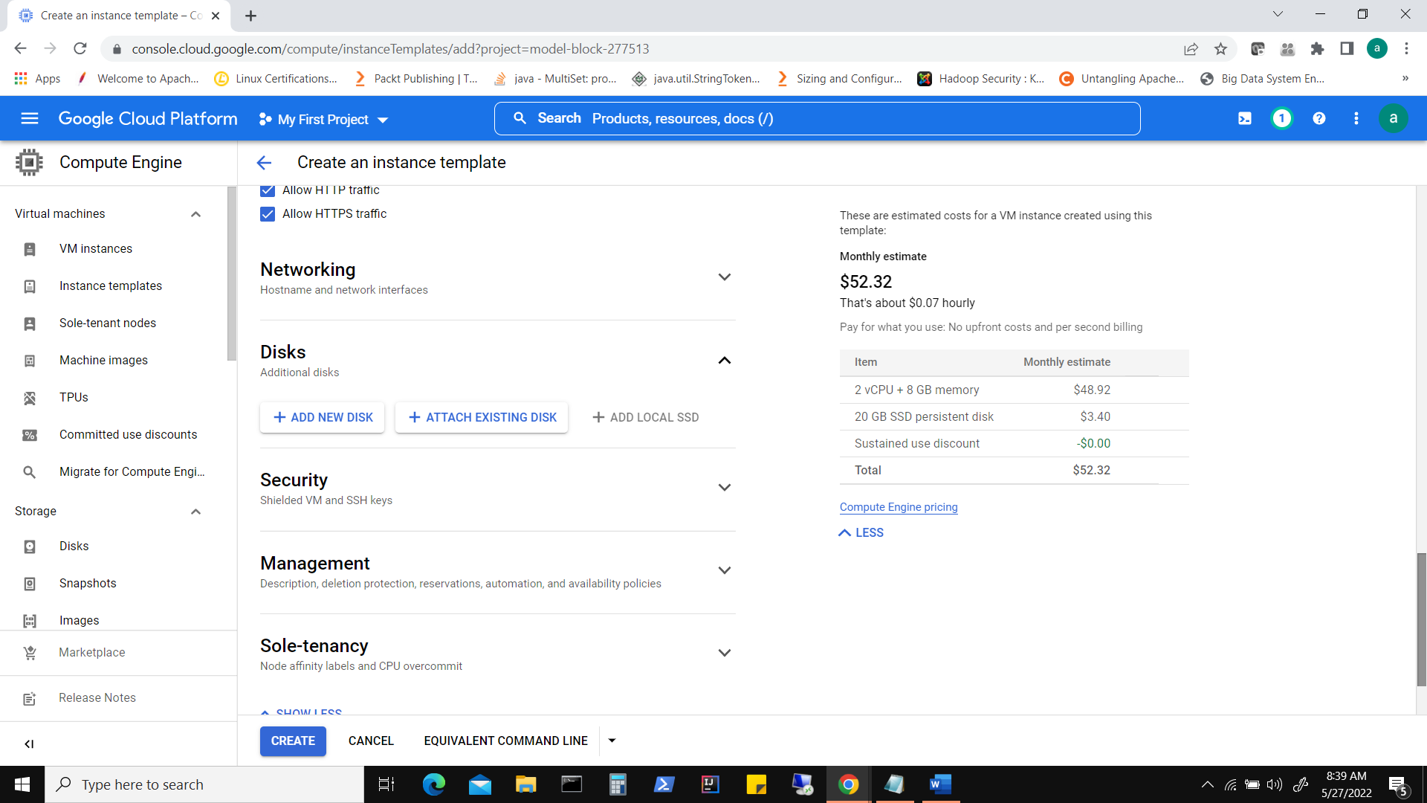

Note** In ‘Add manually generated SSH keys’ section, we can click on Add Item and add ‘additional ssh public key’ in order to use an external client like putty to connect to machine.

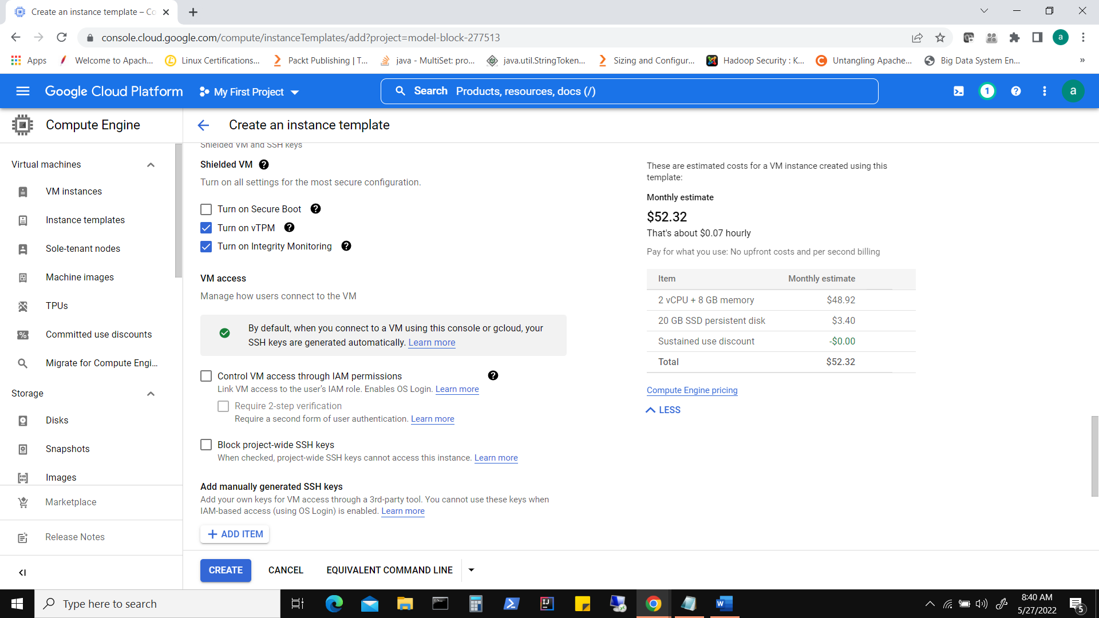

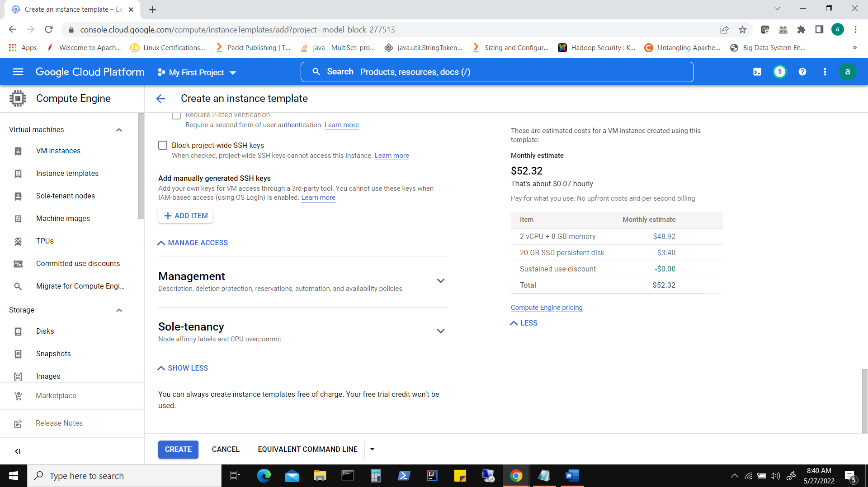

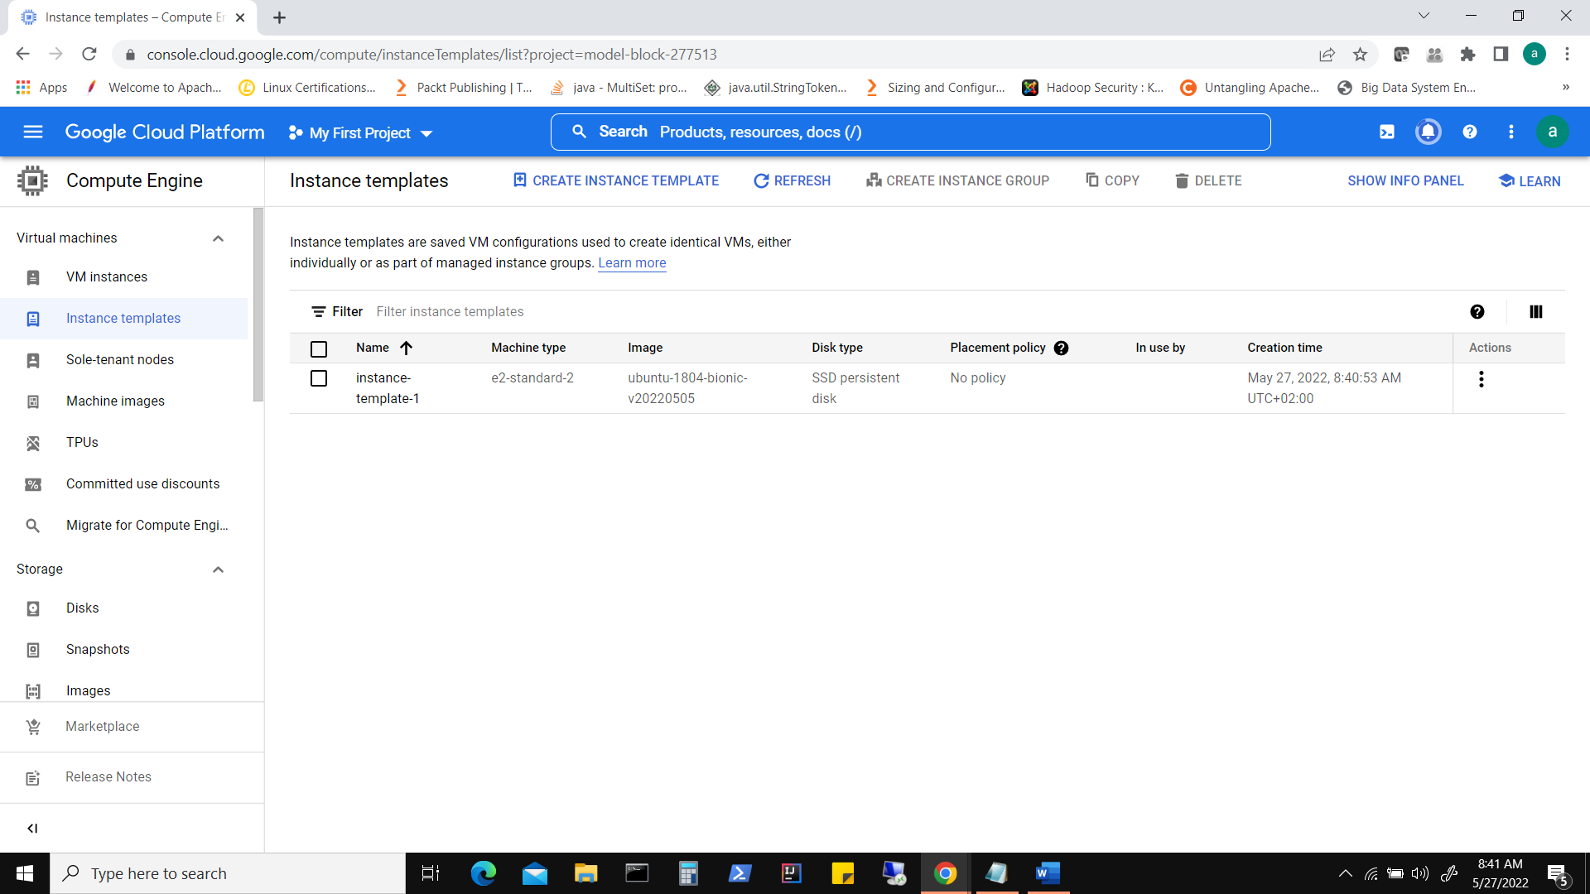

**Now Create an instance**

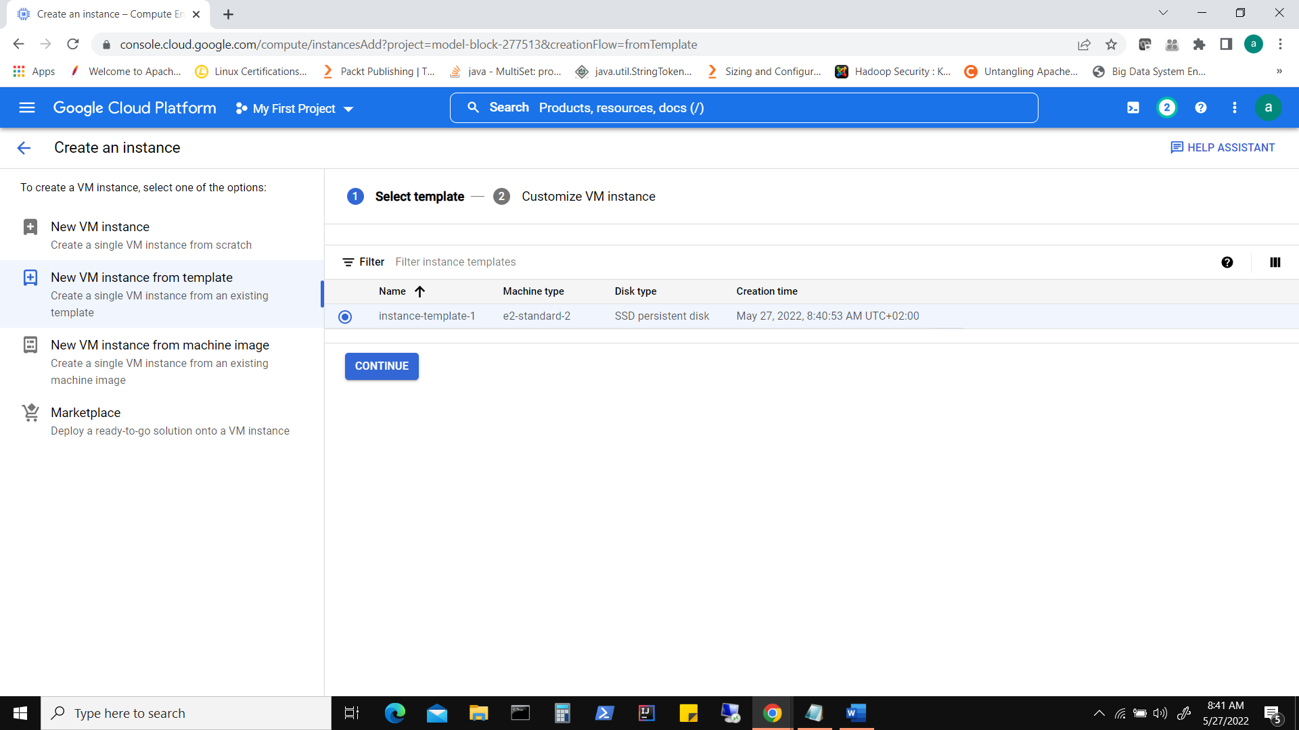

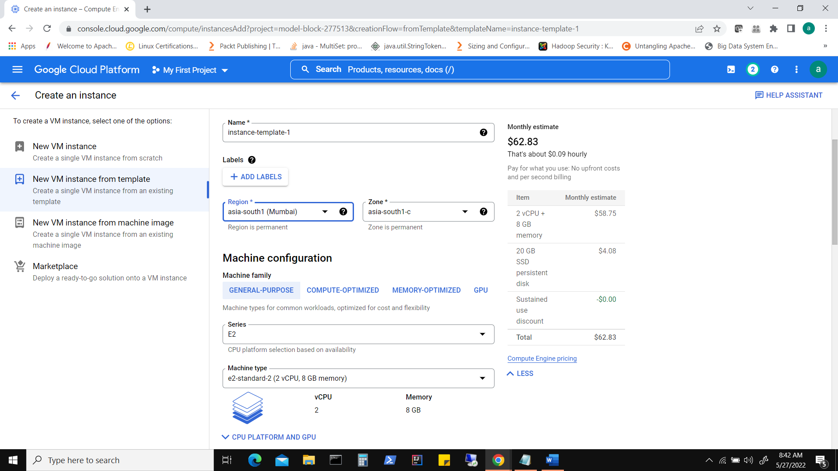

Once instance is created, view/edit network details .

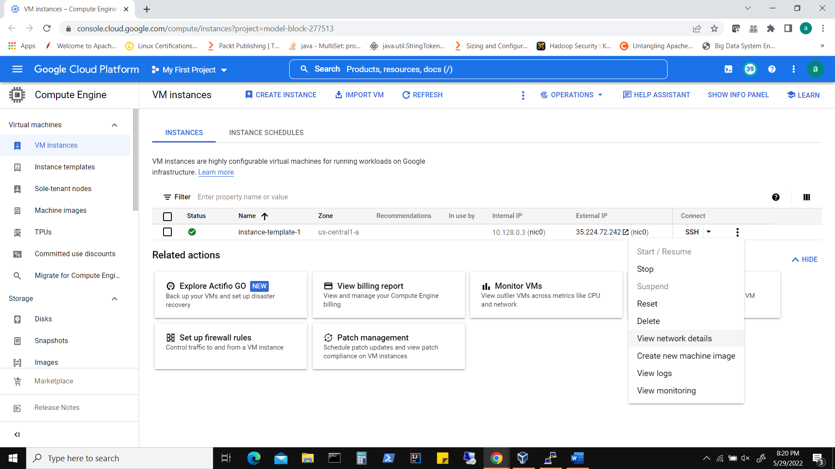

To begin with we can keep defaults and basic firewall rules to allow SSH, HTTP & HTTPS

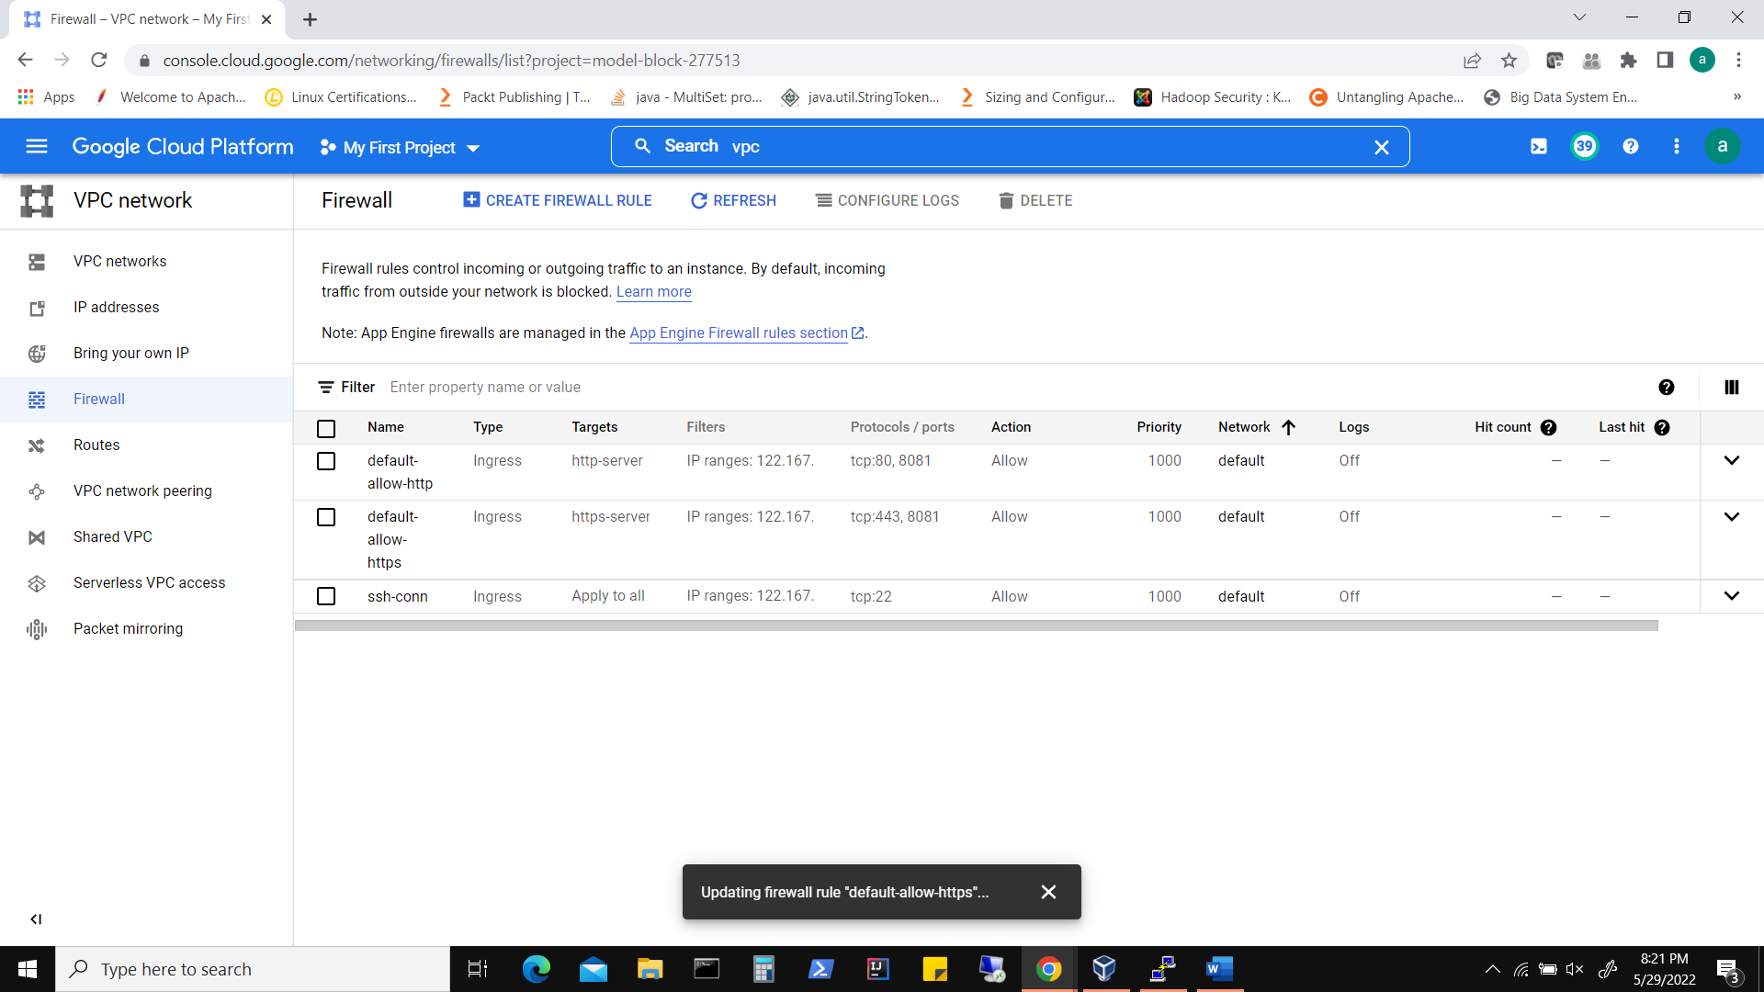

Now we should be able to connect to our instance using say PUTTY.

**To connect from Linux:**

Download the provided *.pem file(for linux) or *.ppk (for putty)

If using *.pem, change permissions ‘chmod 400 *.pem’

Connect ‘ssh –i *.pem hdu@<ipaddress>’